CSE 581

**Lab 5: System Functions Exercise**

*Do this lab against the Northwind database.*

***For the entire lab, provide all of your SQL as text, inserted at the beginning of the document.***

***For each step also provide a screenshot of execution, showing the SQL and the results.***

***Please make sure both the SQL and the screenshots are marked w/ the question number that they are answering.***

**Steps:**

1. List all employee names in the following format: LAST NAME, first name. (Uppercased last name, followed by comma and space, followed by lowercased first name).

select concat(upper(lastname),',',' ', lower(firstname))

FROM employees;

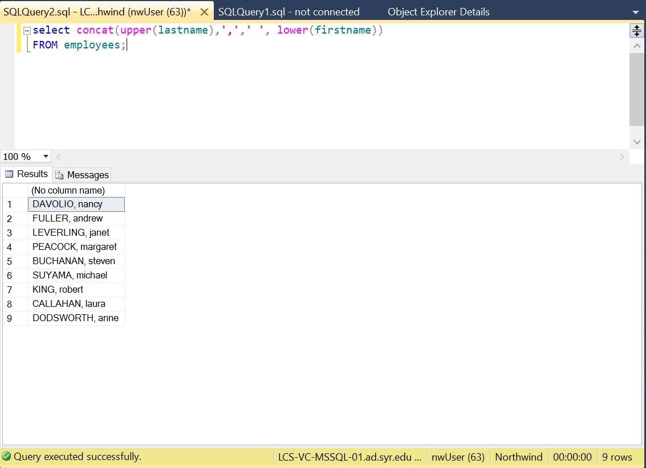

1. List all company names as well as the length of their name, from the Customers table. 2 Columns – Company Name, Text length.

select CompanyName, LEN(COMPANYNAME)

FROM Customers;

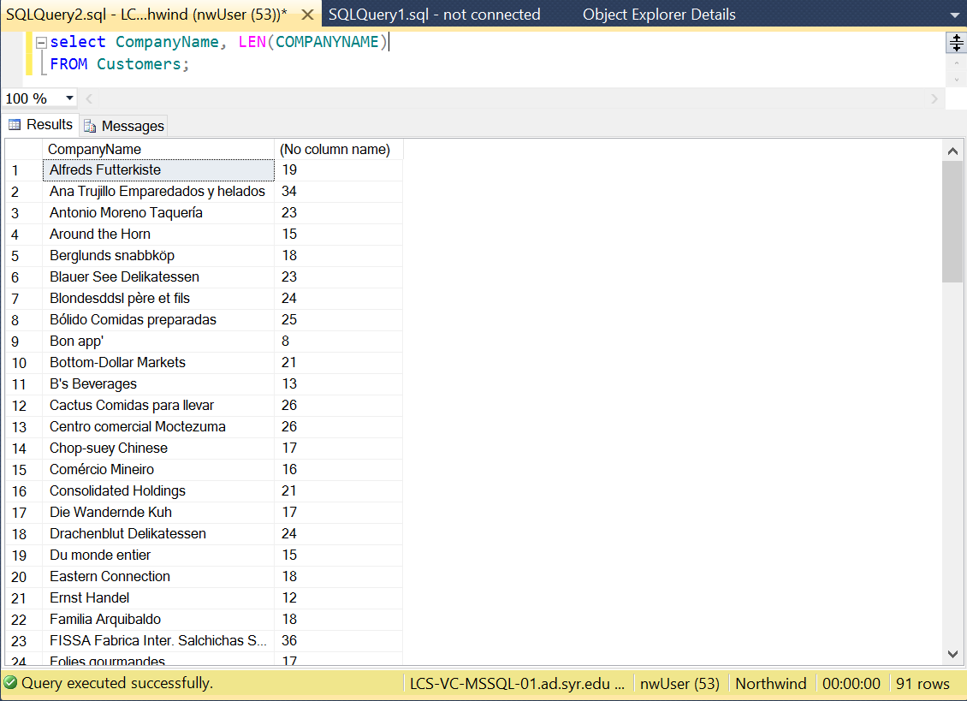

1. List all shipped dates as well as expected delivery dates from the Orders table WHERE SHIP DATE is present. (Expected delivery date is 5 days from the ship date).

select SHIPPEDDATE, DATEADD(DAY,5,SHIPPEDDATE) AS 'Expected delivery date'

FROM ORDERS

WHERE SHIPPEDDATE IS NOT NULL;

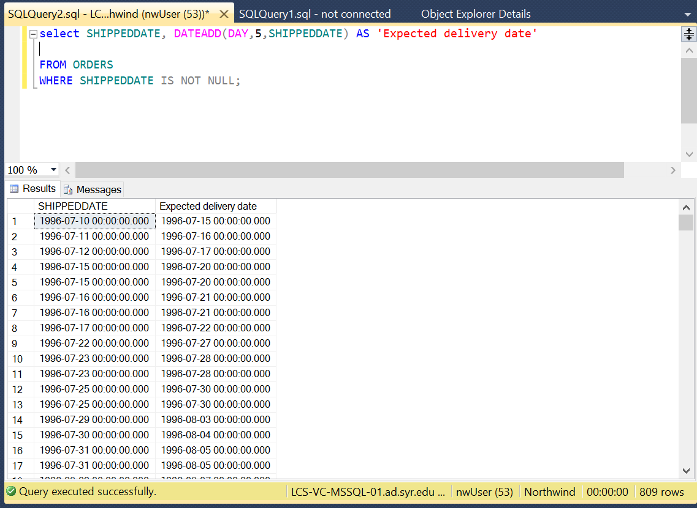

1. List all orders from the Orders table that were shipped in 1998.

SELECT *

FROM ORDERS

WHERE YEAR(SHIPPEDDATE) = '1998';

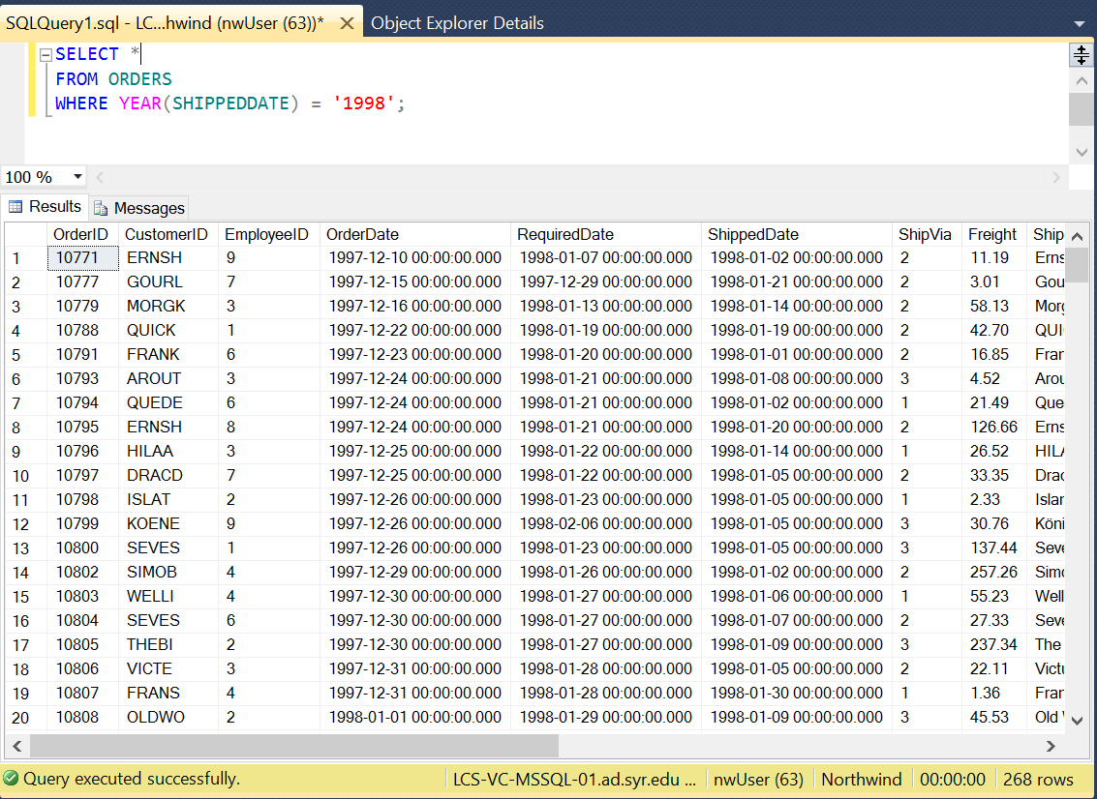

1. List all orders placed on January 1st 1997, from the Orders table.

SELECT *

FROM ORDERS

WHERE (YEAR(ORDERDATE) = 1997)AND DAY(ORDERDATE)=1 AND MONTH(ORDERDATE)=1 ;

